**VISVESVARAYA TECHNOLOGICAL UNIVERSITY**

**Jnana Sangama, Belgavi – 590014.**



**MINI PROJECT REPORT**

**ON**

“Responsive Offline Clone Payment System**”**

Submitted in partial fulfillment for the requirement of VII semester for the

**Degree of Bachelor of Engineering in**

**COMPUTER SCIENCE & ENGINEERING**

For the academic year 2018-2019

**SUBMITTED BY:**

ROSHAN ZAMEER

**(VII** Semester**)**

**Under the guidance of:**

MRS. SHRUTI G

**Assistance Professor,**

**Department of CSE**



**DON BOSCO INSTITUE OF TECHNOLOGY, BENGALURU-74DON BOSCO INSTITUTE OF TECHNOLOGY**

**Kumbalagodu, Bengaluru-560074**



**DEPARTMNET OF COMPUTER SCIENCE AND ENGINEERING**

CERTIFICATE

This is to certify that the Project Report entitled **“INSTANT PAYMENT SYSTEM”** Is a bonafide Project work carried out by **ROSHAN ZAMEER(1DB15CS127)**, in partial fulfillment of VII semester for the Degree of **Bachelor of Engineering in Computer Science and Engineering** of Visvesvaraya Technological University, Belgavi, during the academic year 2018-2019. It is certified that all corrections/suggestions indicated for Internal Assessments have been incorporated with the degree mentioned.

**Project Guide Head of Department**

**MRS. SHRUTI G Prof. B.S Umashankar**

Asst.Prof,Dept of CSE, Head of Department

Dept,of CSE, Dept, of CSE,

DBIT,Banglore. DBIT,Banglore.

**External Viva**

**Name of the Examiners Signature with Date**

1._________________ _________________

2._________________ _________________

**DON BOSCO INSTITUE OF TECHNOLOGY**

**Kumbalgodu, Bengaluru -560074.**



**DECLARATION**

I, **ROSHAN ZAMEER**, student of Seventh semester B.E, Department of Computer Science and Engineering, Don Bosco Institute of Technology, Kumbalagodu, Bengaluru, declare that the Project Work entitled **“INSTANT PAYMENT SYSTEM”** has been carried out by and submitted in partial fulfillment of the requirement of VII semester Aug 2018- Dec 2019. The matter embodied in this report has been submitted to any university or institute for the award of any other degree or diploma.

**Place:** Bengaluru **ROSHAN ZAMEER**

**Date: (1DB15CS127)**

**ACKNOWLEDGEMENT**

At the various stages in doing the mini project, a number of people have given me invaluable comment on the manuscript. I take this opportunity to express my deepest gratitude and appreciation to all those who helped me directly or indirectly towards the successful completion of this project.

I would like to thank Principal, Don Bosco Institute of Technology for his support though out this project.

I express my wholehearted gratitude to Prof. B.S.UMASHANKAR, Prof. & Head of Department of CSE, who is our respectable Head of Dept of Computer Science. I wish to acknowledge for his valuable help and encouragement.

In this regard I owe a heartfelt gratitude to my guide Professors of Department of Computer Science and Engineering, for her timely advice on the project and regular assistance throughout the project work. I would also like to thank the staff members of Department of Computer Science and Engineering for their corporation.

**ABSTRACT**

The main aim and objective was to plan and Program System application .We have to apply the best software engineering practice for system application. I developed “INSTANT PAYMENT SYSTEM” using HTML, CSS, JavaScript and Python.

The “INSTANT PAYMENT SYSTEM” is an Online Payment, Platform that used to make payment of different types like, deposit and Checking balance statement.

The Project “INSTANT PAYMENT SYSTEM” have been clear influences on the demand for instant payments.  The spread of smartphones has meant that now, more than at any other time, customer expectations are high. Individuals expect to be able to make a payment anywhere and at any time, including during evening hours, weekends and on public holidays. They also want to be able to pay for and receive their purchases as fast as possible. Suppliers, on the other hand, want the certainty of payment as soon they release their goods and services.

**CONTENTS**

1. **Introduction** 7
2. **Project Analysis** 9
3. **Schema Diagram** 11
4. **E-R Diagram** 12
5. **Data Tables** 13
6. **Snap Shots** 23
7. **Conclusion** 29
8. **Reference Book** 30
9. **INTRODUCTION**

Techciti Technologies Private Limited is a Private incorporated on 05 April 2013. It is classified as Non-govt company and is registered at Registrar of Companies, Bangalore. Its authorized share capital is Rs. 100,000 and its paid up capital is Rs. 100,000.It is inolved in Software publishing, consultancy and supply [Software publishing includes production, supply and documentation of ready-made (non-customized) software, operating systems software, business & other applications software, computer games software for all platforms. Consultancy includes providing the best solution in the form of custom software after analyzing the user’s needs and problems. Custom software also includes made-to-order software based on orders from specific users. Also, included are writing of software of any kind following directives of the users; software maintenance, web-page design].

Techciti Technologies Private Limited's Annual General Meeting (AGM) was last held on 28 September 2017 and as per records from Ministry of Corporate Affairs (MCA), its balance sheet was last filed on 31 March 2017.

Directors of Techciti Technologies Private Limited are Baidehi Ann Roy, Paritosh Kashyap Kumar and Our multi-skilled engineers have expertise across a wide range of technologies, which when coupled with our tightly controlled processes and delivery model, add value to the engineering efforts of our clients. Leveraging standards-based components and investments in dedicated test lab infrastructure, we offer innovative, flexible and cost-effective Embedded Services and solutions.

* 1. **Aim**

Instant payments focus on low value retail payment systems (RPS); they differ from real-time gross settlement systems (RTGS) and distributed ledger payment systems. The generally accepted definition of instant payments, is that systems have the following

characteristics.

* 1. **Objective**

The main objective was to create a unique and useful “**Responsive Offline Clone Payment System**” the payer initiates the payment, they are informed immediately (within a few seconds) whether the payment has successfully reached the payee’s account or not..

* 1. **Scope:**

**Responsive Offline Clone Payment System** is a new way to exchange money and purchase services in seconds. Compared with wire transfers they allow the transfer of money from the payer bank account to the payee bank account almost immediately, instead of requiring few business days. These payment systems have been developed (and are currently under development) worldwide as the need of faster and reliable transaction is the new economy common requirement.

* 1. **Existing System:**

**Responsive Offline Clone Payment System** is one of the leading payments service aggregator in a country .We provide a seamless Single sign-on API /Web Service for all your Utilities and Payments needs especially the following Prepaid Recharges (Mobile, DTH and Data card), Bill Payments (Mobile, Data Card, Landline), Domestic Money Transfer, Electricity & Gas Nationwide, Travel Ticketing, Hotel Booking, Connection Sales (DTH), Prepaid Cards & Gift Cards, Insurance Premium Collection.

* 1. **Proposed System:**

**Responsive Offline Clone Payment System** Notification (IPN) is a message service that automatically notifies merchants of events related to **PayPal** transactions. Merchants can use it to automate back-office and administrative functions, including automatically fulfilling orders and providing customers with order status.

**1.6.1 Advantages**

This Project is beneficial for companies that provide Revenue of particular companies

1. Decreases the time consumption.

2. Improves Efficiency- It improves efficiency.

3. Occurrences of Error is Minimize.

4. Decreases the paper and labor work.

5. Manage the entire process.

**1.6.2 Disadvantages**

1. It’s too tiring to give Computerized Timing.

2. Security Limitation.

**2. PROJECT ANALYSIS**

**Task Assignment**

I have done my internship program from July 6 2018 to August 6 2018.After a one month training, I was introduced to different projects which the company is going to handle. I got a chance to select a project on my area of interest. The topic which I selected was **Responsive Offline Clone Payment System.** Regarding this we were given the instruction about the requirements and had to develop based on it. This was really a new experience that I came across so far because giving a name, designing logos where really interesting. We were also free to come up with our own ideas if any.

**2.1 Project Description:**

The growth of e-commerce has caused changes in people's spending patterns. Shopping is no longer confined to regular business hours, creating a new challenges for funds transfers. Similarly, merchants require faster and more reliable money transfer systems to keep up with consumer demand.

Traditional electronic payments like wire transfers that perform the electronic funds transfer within few business days, are not in line with user expectations. It is predicted that in the next year instant payments will become the standard for electronic fund transfers.

**2.2 Requirement Specification:**

To run this project on various platform we need some hardware and software to support this project.

**2.2.1 Hardware Specification**

**Processor**: Intel i3

**RAM**-1 GB

**Memory**: 10GB

**2.2.2 Software Specification**

Database: SQL

Language: Html, CSS, JavaScript and Python

IDE: VS Code, Python 3.4

**2.3 System Constraints:**

**2.3.1 User Interface Constraints**

Using this application is simple and intuitive. A user familiar with system application can understand the functionality provided by the application.

**2.3.2 Hardware Constraints**

The portal should work on most home desktop and laptop computers.

**2.3.3 Software Constraints**

The portal is designed to run only in browsers.

**2.3.4 Data Management Constraints**

Portal shall be able to interface with other components according to their specifications.

**2.3.5 Design Standard Compliance**

The portal shall be implemented in Html and CSS.

2.4 **Learning Experience:**

The internship duration was from 6-7-18 to 6-8-18.The head of the Responsive Offline Clone Payment System department gave an overview about the company details and the different projects they handled. The company has people working on WEB projects as well. The internship started with the basic training given by the faculties about various software and current projects handled by the embedded department.

The internship provided a learning opportunity to apply the knowledge and skills acquired in the classroom to a professional context, identify and understand the practices and protocols of the TECHCITI company. As I have done my internship program in KNOWX I have spent 16 weeks in that company. The first 4 weeks a training on several concepts like basic C programming, Python in Raspberry.

2.4 **Non Functional Requirements:**

Non functional requirements are the functions offered by the system. It includes time constraints and constraints on the development process and standards. The non functional requirements are as follows:

* **Speed:** The system should process the given input into output within appropriate time.
* **Ease of use:** The software should be user friendly. Then the customers can use easily,

so it doesn’t require much training time.

* **Reliability:** The rate of failures should be less then only the system is more reliable
* **Portability**: It should be easy to implement in any system.

**3. SCHEMA DIAGRAM**

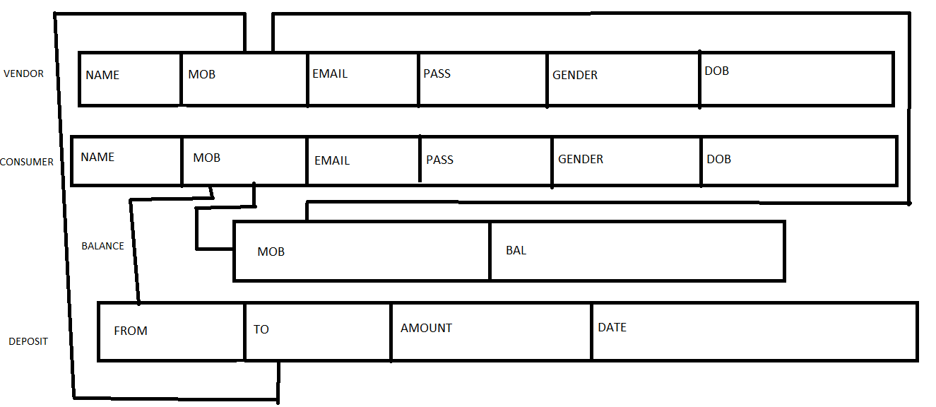

**4. E-R DIAGRAM**

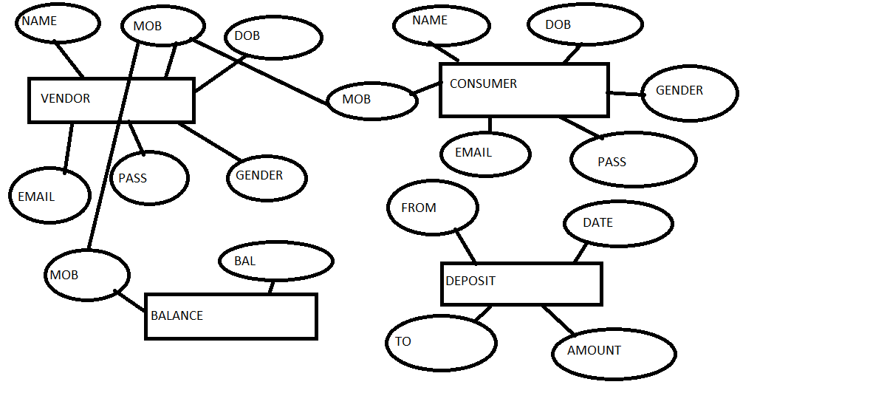

**5. DATA TABLES**

**VENDOR**:

|  |  |  |  |
| --- | --- | --- | --- |
| S.No. | Field Name | Data Type | Description |
| 1 | NAME | char | Store the name of Vendor |
| 2 | MOBILE | Varchar | Store the Mobile no. |
| 3 | EMAIL | char | Store the email Id |
| 4 | GENDER | char | Store the gender detail |
| 5 | PASSWORD | varchar | Store the password |
| 6 | DOB | varchar | Store the Date of birth |

**CONSUMER:**

|  |  |  |  |
| --- | --- | --- | --- |
| S.No. | Field Name | Data Type | Description |
| 1 | NAME | char | Store the name of Consumer |
| 2 | MOBILE | varchar | Store the Mobile no. |
| 3 | EMAIL | char | Store the email Id |
| 4 | GENDER | char | Store the gender detail |
| 5 | DOB | varchar | Store the Date of birth |
| 7 | PASSWORD | varchar | Store the password |

**BALANCE:**

|  |  |  |  |
| --- | --- | --- | --- |
| S.No. | Field Name | Data Type | Description |
| 1 | MOBILE | int | Store the mobile no. |
| 2 | BALANCE | varchar | Store the balance in Account |

**DEPOSIT:**

|  |  |  |  |
| --- | --- | --- | --- |
| S.No. | Field Name | Data Type | Description |
| 1 | FROM | char | Contain parent account |
| 2 | TO | char | Contain transfer child account |
| 3 | AMOUNT | int | Contain remaining amount |
| 4 | DATE | int | Store the Date of transfer |

**5. SOURCE CODES:**

**#!C:/Python34/python**

**import cgi**

**import mysql.connector**

**print("Content-type:text/html")**

**print("")**

**form = cgi.FieldStorage()**

**a = form.getvalue("amount")**

**cmo = form.getvalue("cmobile")**

**vmo = form.getvalue("vmobile")**

**vmo=int(vmo)**

**w='d'**

**k=int(a)**

**cmo=int(cmo)**

**a=int(a)**

**print("""**

**<html>**

**<head>**

**<style>**

**body {font-family: Arial, Helvetica, sans-serif;}**

**ul {**

**list-style-type: none;**

**margin: 0;**

**padding: 0;**

**overflow: hidden;**

**background-color: #333;**

**}**

**li {**

**float: left;**

**}**

**li a {**

**display: block;**

**color: white;**

**text-align: center;**

**padding: 14px 16px;**

**text-decoration: none;**

**}**

**/* Change the link color to #111 (black) on hover */**

**li a:hover {**

**background-color: #111;**

**}**

**.active {**

**background-color: #4CAF50;**

**}**

**li {**

**border-right: 1px solid #bbb;**

**}**

**li:last-child {**

**border-right: none;**

**}**

**ul {**

**position: fixed;**

**top: 0;**

**width: 100%;**

**}**

**</style>**

**</head>**

**<body background="001.png" style="background-position: center;**

**background-repeat: no-repeat;**

**background-size: cover;">**

**<br><br>**

**<ul>**

**<li><a href="user_home.html">Home</a></li>**

**<li><a href="udeposit.html">deposit</a></li>**

**<li><a href="uview.html">View Deposit</a></li>**

**<li style="float:right"><a class="active" href="home_page.html">Logout</a></li>**

**</ul>**

**""");**

**cnx=mysql.connector.connect(user='root', password='', host='localhost', database='offline')**

**cursor=cnx.cursor()**

**from datetime import datetime**

**today=datetime.now()**

**val = (k, vmo)**

**seq=(cmo, vmo, k, w, today)**

**c=0**

**cursor.execute("""select * from balance""");**

**r=[]**

**a1=[]**

**a2=[]**

**for row in cursor:**

**r.append(row)**

**try:**

**for i in r:**

**if(i[0]==vmo):**

**a1=int(i[1])**

**for i in r:**

**if(i[0]==cmo):**

**a2=int(i[1])**

**except:**

**print("<script>alert('transfer declined')</script>");**

**c=1**

**updatedc=a2-k**

**updatedv=a1+k**

**val1=(updatedc,cmo)**

**val2=(updatedv,vmo)**

**count=-1**

**cursor.execute("""update balance set bal=%s where mob=%s""",val1);**

**count=cursor.rowcount**

**cursor.execute("""update balance set bal=%s where mob=%s""",val2);**

**count=cursor.rowcount**

**if count>=-1:**

**print("<script>alert('SUCCESSFULLY TRANSFERED')</script>");**

**else:**

**print("<script>alert('transfer declined')</script>");**

**c=1**

**cnx.commit();**

**if(c!=1):**

**cursor.execute("""insert into deposit values(%s,%s,%s,%s,%s)""",seq);**

**print("""<h1 align="center"> Instant Money Transfer System</h1>**

**<h3> Your money has been successfully transfered.</h3>**

**<h4>your new balance is :</h4>""")**

**print(updatedc)**

**cnx.commit();**

**cnx.close()**

**print("""**

**</body>**

**</html>**

**""");**

**6. SNAP SHOTS**

**Home page:**

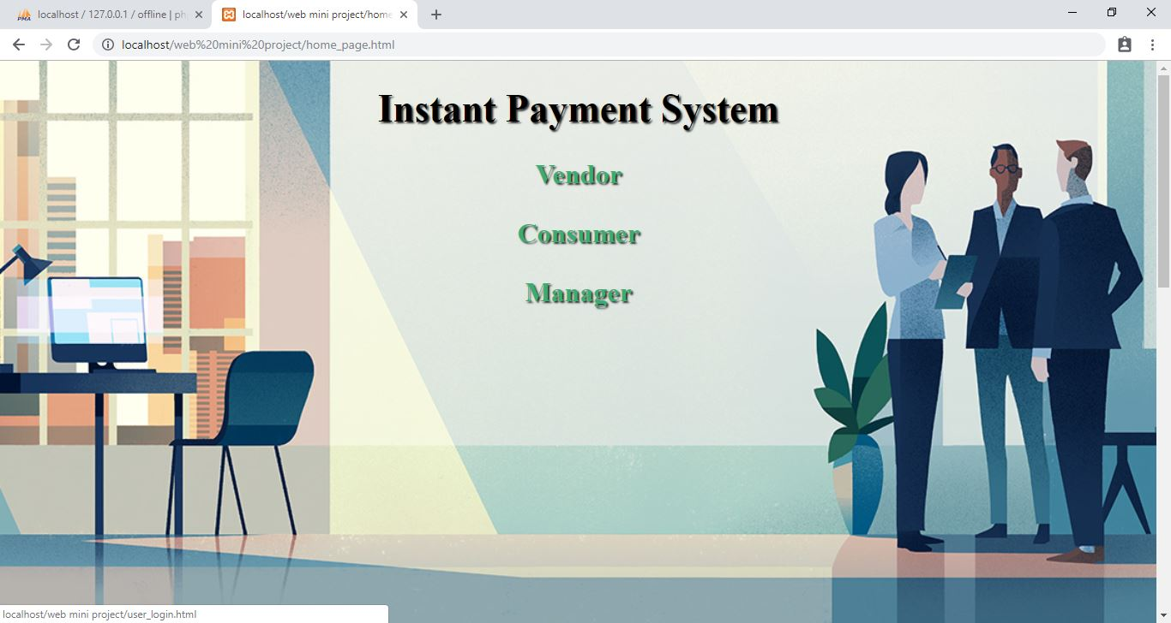

Fig 1

The Home page has Vendor, Customer and Manager that can be access by each of them.

**Vendor Login Page:**

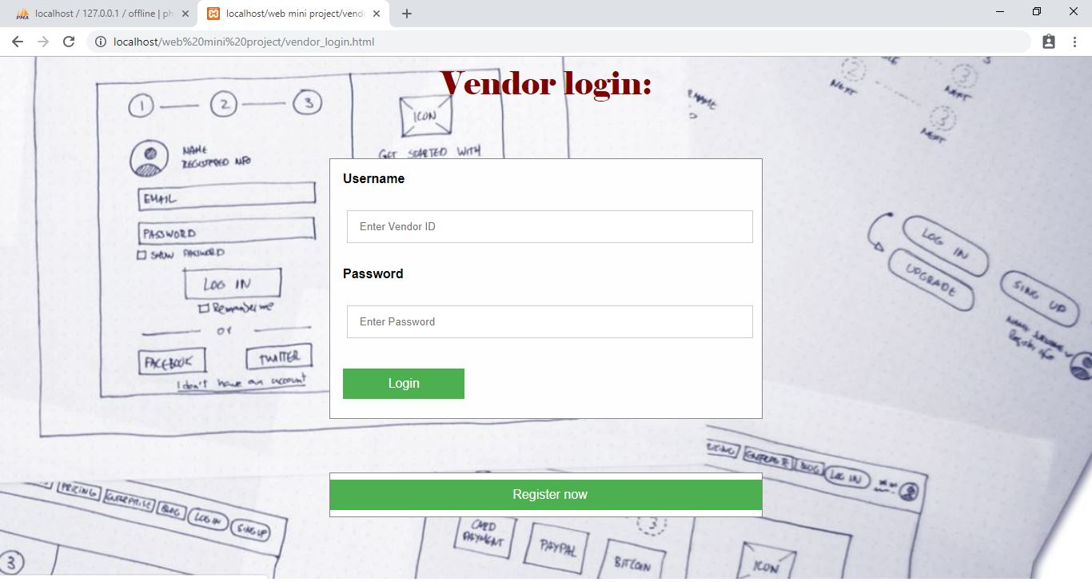

Fig 2

The Page has Vendor Login Id and Password. If the vendor is new to the portal then they can create a new account which will have an initial balance of RS. 0.

**Consumer Login Page:**

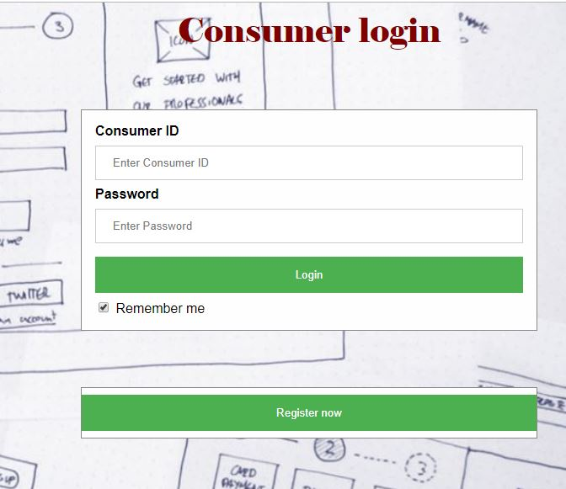

Fig 3

The Page has Consumer Login Id and Password.

**User Registration info:**

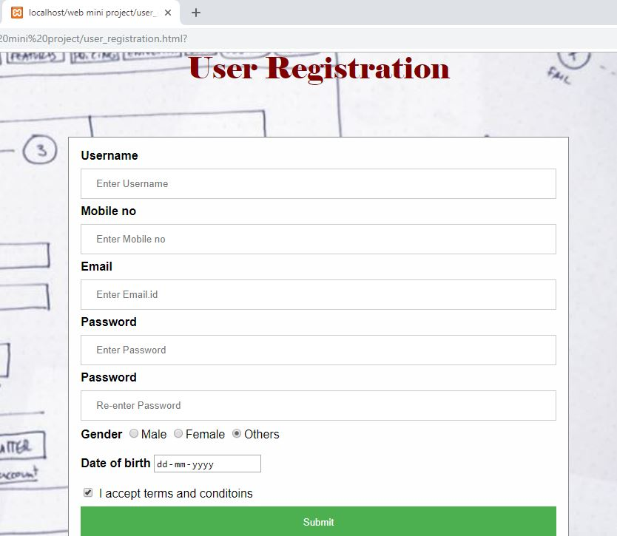

Fig 4

When admin clicks on view button he will get all the information about the Registration info.

**VENDOR WELCOME PAGE:**

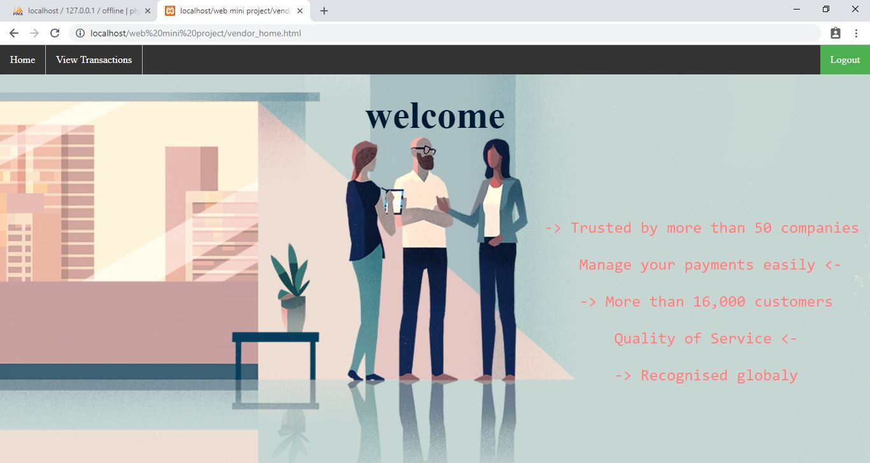

Fig 5

Welcome page of Vendor, as Vendor has been login this welcome page will display.

**DETAIL USING PHONE NO.:**

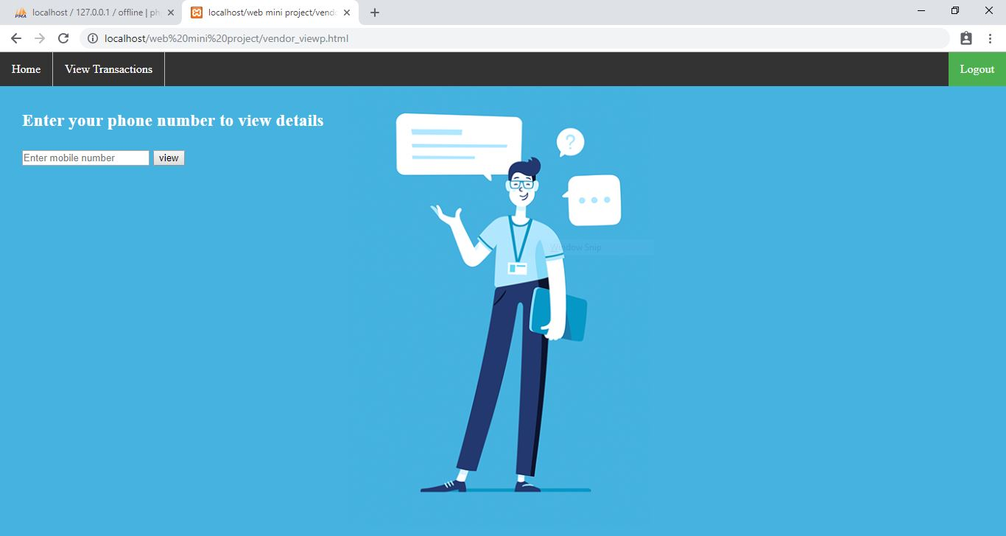

Fig 6

This will shows the detail information using login.

**TRANSCATIONS**:

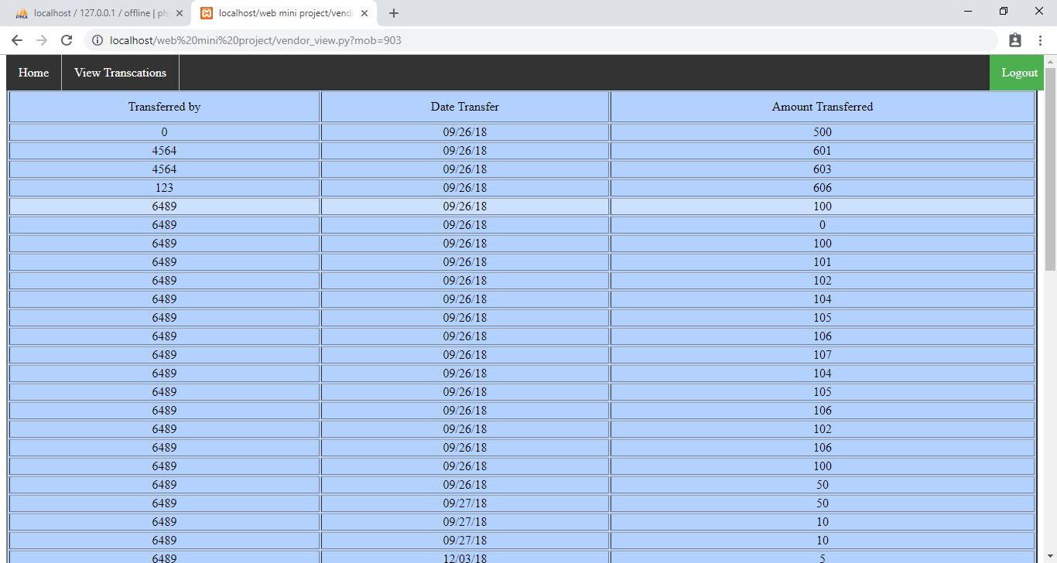

**7.CONCLUSION**

The Project “**Responsive Offline Clone Payment System**” have been clear influences on the demand for instant payments.  The spread of smartphones has meant that now, more than at any other time, customer expectations are high. Individuals expect to be able to make a payment anywhere and at any time, including during evening hours, weekends and on public holidays. They also want to be able to pay for and receive their purchases as fast as possible. Suppliers, on the other hand, want the certainty of payment as soon they release their goods and services.

This change of expectations has also had an impact on services such as banks and payment providers. The reliance on traditional banking has fallen dramatically, with customers demanding more convenience and flexibility. There has been an emergence of new finch payment providers.

These changing consumer attitudes and new technologies have combined to initiate a new era of payments and the roll out of a number of European instant payment schemes. The conclusions are inevitable. If you think Internet banking take-up was rapid, wait till you get a load of mobile payments. Banks and credit card companies are used to owning the infrastructure for payments processing. However, what we are seeing is a deleveraging of the retail payment experience from the back-end banking system. That is, banks are simply no longer going to be necessary when it comes to point-of-sale, neither are credit card companies.

Do you remember payment by instalment, layaway or lay-bys? My kids have never heard of them, and I can’t remember seeing them for at least a decade, but they used to be a popular method of getting through the Christmas credit crunch in the old days. But layaways have mostly disappeared because credit cards were a better idea. Just like layaways under threat from a new payment mechanism, physical credit cards may also be on their way out due to mobile payments.

**8.Reference Book**

1. Banca d'Italia. November 30, 2017. p. 3*. Retrieved September 2, 2018*.
2. [*"What are instant payments?"*](https://www.instapay.today/instant-payments/). www.instapay.today. InstaPay. 2018*. Retrieved September 2, 2018*.
3. [*"Instant payments are the future - here's why"*](https://insights.nordea.com/instant-payments-are-future-heres-why). insights.nordea.com. Nordea. 2018*. Retrieved September 2, 2018*.
4. [*"Instapay Tracker"*](https://www.instapay.today/tracker/). www.instapay.today. InstaPay. 2018*. Retrieved September 2, 2018*.
5. [*"Zenging system"*](https://www.zengin-net.jp/en/zengin_net/zengin_system/). www.zengin-net.jp. Japanese Bank’s Payment Clearing Network. 2012*. Retrieved September 2, 2018*.
6. [*"Japanese Drive Mobile Payment Market"*](http://www.ericsson.com/ericsson/corpinfo/publications/telecomreport/archive/2006/january/valista.shtml). Ericsson.com. 2010-11-02*. Retrieved 2011-09-19*.

**7.**  [*Mobile payment system*](https://patents.google.com/patent/US20020073027A1/en), 2000-12-11*, retrieved 2018-06-08*

**8.**  [*"Total Mobile Payments to Grow Nearly Ten Fold by 2013"*](http://www.juniperresearch.com/shop/viewpressrelease.php?pr=106). Juniper Research.

**9.**  [*"Research shows mobile phone payment double by 2013"*](http://www.bonsoni.com/blog/research-shows-mobile-phone-payment-double-by-2013/). Bonsoni.com. 2011-07-24*.*.

**10.** [*"Mobile Payment Transaction Values for Digital and Physical Goods to Exceed $300bn Globally Within 5 Years"*](http://www.juniperresearch.com/shop/viewpressrelease.php?id=128&pr=97). Juniper Research.

**11.**  [Investment on Mobile Money Services Anticipated to touch 22.2% by 2018](http://www.marketreportsworld.com/mobile-money-emerging-trends-growth-drivers-and-future-outlook-10156044) Retrieved 06-06-2016